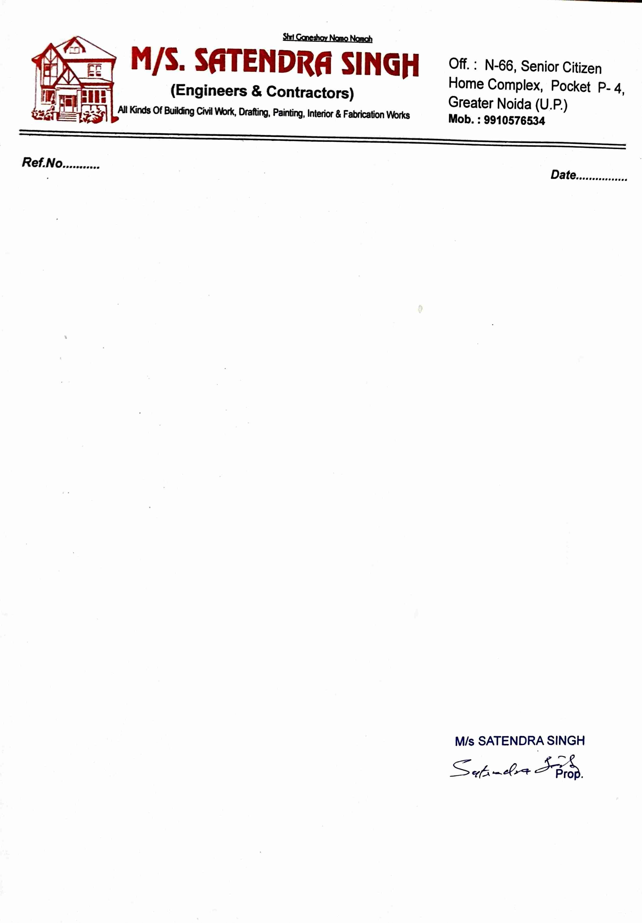
TO WHOMSOEVER IT MAY CONCERN
This is to certify that Mr. Rahul Rawat was engaged as a Frontend Developer Intern at SS (Engineers
& Contractors) from February 2023 to August 2023.
During his internship, Rahul worked with our frontend team on internal product development,
primarily contributing to two areas: our Data Dashboards and Analytics platform and our Employee
Portals. He built and improved UI components, worked closely with our senior developers to
familiarize himself with the codebase and development practices, and gradually took ownership of
small features under supervision.
Rahul was sincere and receptive to feedback throughout his time with us. He wrote tests for the code
he worked on, addressed bugs raised during code review, and consistently delivered the tasks assigned
to him within expected timelines. He demonstrated a good understanding of React and modern
frontend workflows for someone at his career stage.
We wish him the very best in his future endeavors.
Sincerely,

